Simulation and Connectivity Inference in Clustered Spiking Networks

1. Methods

1.1 Network model
Networks were built as single-compartment Hodgkin-Huxley neurons (80% excitatory, 20% inhibitory) embedded in a two-dimensional space with distance-dependent, cluster-structured connectivity. Each neuron carried a Kv4-like A-type potassium current, a dynamic extracellular-potassium mechanism, and a two-timescale spike-triggered adaptation current with a fast M-like component (tau = 300 ms) and a slow Ca2+-dependent component (tau = 6500 ms). Excitatory transmission used a combined AMPA/NMDA synapse with short-term depression; inhibitory transmission used a single-exponential conductance with reversal at -75 mV. A per-neuron log-normal connection propensity produced heavy-tailed out-degrees without a bimodal hub class.
Twenty independent networks were generated. Ten used 50 spatial clusters in a 15.0-unit square; ten used 40 clusters in a 13.416-unit square, the side scaled as the square root of 40/50 so that neuron density remained constant across the two groups. Realized sizes spanned 758-1010 neurons (50-cluster group, wiring density 1.51-1.72%) and 629-918 neurons (40-cluster group, 1.84-2.10%), with 8,182-15,894 directed synapses per network. Topology seeds 1-10 and 11-20 respectively were recorded in each saved network file along with the full builder parameter set.
Background drive was the sole input: an independent Poisson generator per neuron (rate 5 Hz, peak conductance 0.007 uS) delivered through an excitatory conductance. Each generator drew from a Random123(base, gid, recording_index) stream, with base = 1000 + 100 x topology_seed, making every recording an independent trial and every network's noise distinct.

1.2 The two states
Normal and seizure states differ in exactly two parameters, both belonging to the slow AHP:
parameter | normal | seizure | role
sahp_ainc_slow | 0.010 uS | 0.004 uS | per-spike increment; recruitment depth
sahp_tau_slow | 6500 ms | 3000 ms | decay constant; recovery clock, burst frequency

Network structure, synaptic parameters, A-current density, fast adaptation, potassium clearance (tau_k = 200 ms), and the per-recording noise streams were held identical. Seizure recording n therefore shares its exact background realization with normal recording n, giving a paired design in which state is the only difference. Biologically the manipulation represents an acquired reduction of Ca2+-dependent K+ (KCa) conductance, of the kind reported in post-status-epilepticus hippocampus; it is deliberately not a channel-blocker model.

1.3 Dataset generation
Each network was recorded for 200 x 60 s in each state (dt = 0.05 ms, 1 s startup transient discarded, membrane voltage sampled at 1 ms), yielding 8,000 recordings across 40 datasets. Generation was distributed on the UW-Madison CHTC HTCondor pool as one job per recording, each rebuilding its network deterministically from the recorded seeds inside a fixed Apptainer image with a pinned NumPy version; median job wall time was approximately 17 minutes. Outputs returned through standard file transfer and were validated per recording before entry into the dataset.

1.4 Network-burst detection
Population activity was binned at 5 ms and expressed as the fraction of distinct neurons active per bin. Candidate events were bracketed wherever that fraction reached 1%, merged across gaps shorter than 100 ms, and padded by 10 ms. Acceptance used a statistical criterion rather than a fixed participation cut: an event was retained when its peak active fraction exceeded the recording's own background level, estimated as median + 5 x MAD over bins outside all candidate windows, and when at least 10% of neurons participated. Retained events were classified as full (participation above 0.35, the conventional definition) or partial.
This change matters for interpretation. A fixed 0.35 gate discards low-recruitment population events entirely, which in quiet networks removes most of the activity structure; the statistical gate keeps them and labels them.

1.5 Connectivity inference
Spikes were binned at 5 ms and fitted with a lag-resolved ridge regression predicting each neuron's activity from all neurons' activity at lags 1-6 (ridge penalty 2.0), implemented sparsely so that all 200 recordings entered a single joint fit. Edge scores took the summed coefficient magnitude over lags 1-4. Thresholds were set without ground truth: eight surrogates were generated by 25 ms interval jitter, and the threshold was the smallest score whose surrogate-derived false-discovery estimate fell below 0.70. Two protocols were evaluated: an untyped protocol thresholding the score matrix directly, and a typed protocol inferring per-neuron E/I identity before applying class-specific thresholds. Performance was measured against the exact wired graph.
A burst-excluded arm repeated the identical procedure after removing each recording's detected burst windows (plus or minus 25 ms), with every retained interval treated as a separate segment so that lagged predictors never bridged a cut.

2. Results

2.1 The manipulation produces a distinct, reproducible phenotype
Across all 20 networks, the two-parameter sAHP change raised mean firing from 0.294 Hz (range 0.261-0.360) to 1.687 Hz (1.580-1.773), a mean increase of 5.77-fold (4.89-6.25). Network-burst rate rose from 9.41 to 25.48 events per 60 s recording. Mean burst duration tripled, 149 ms to 442 ms. Participation rose from 0.51 to 0.95.
The change in variability is as informative as the change in means. In the normal state, burst participation spanned 0.27-0.91 across networks: a threefold spread produced entirely by topology, since all other parameters were identical. That spread collapsed to 0.88-0.98 under the seizure manipulation. Weakening slow adaptation therefore does more than intensify each network's behavior; it overrides the structural determinants of recruitment, driving every realization to near-complete participation.
Event rate, in contrast, was similar across networks even in the normal state (7.5-12.6 per minute) once partial events were counted. What topology controls in this model is how many neurons each population event recruits, not how often events occur.
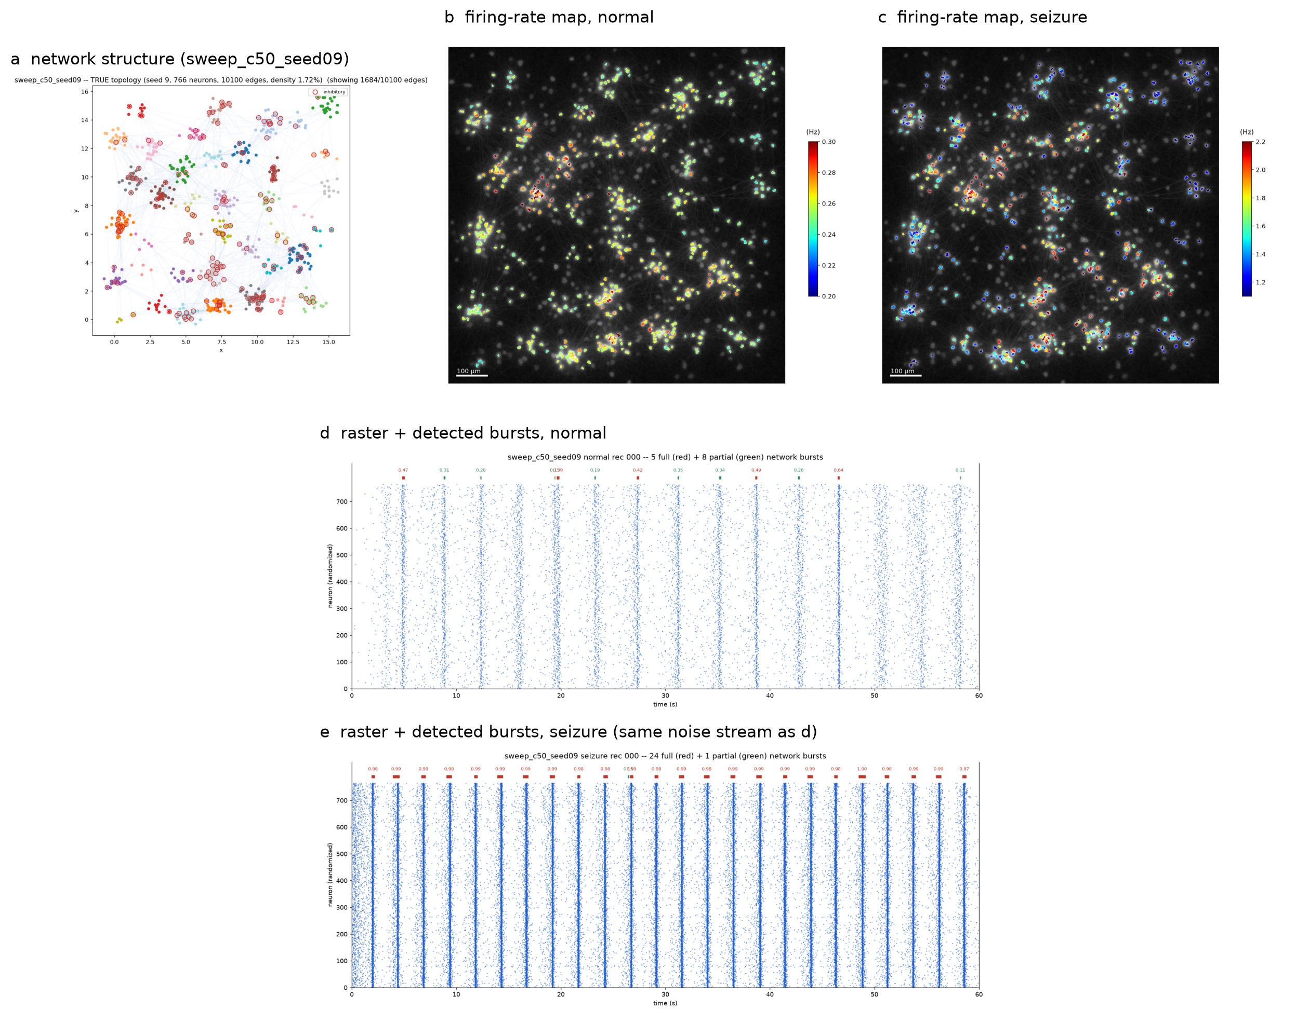
Figure 1. Model and states. (a) True wiring of a representative 50-cluster network; cluster colors, inhibitory somata outlined. (b, c) Field-of-view maps of the same network colored by per-neuron firing rate, normal and seizure; the grayscale background is synthesized for presentation, while ROI positions and rates are simulated quantities. (d, e) Burst-marked rasters of one 60 s recording per state, neuron order randomized; bars above each raster mark detected events (red, full participation above 0.35; green, partial), labelled with participation. Both recordings use identical background noise streams.
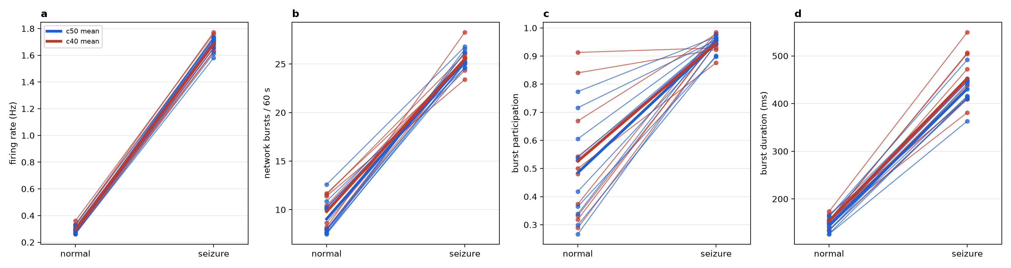
Figure 2. Phenotype across all 20 networks. Paired slope plots, one line per network (blue, 50-cluster group; red, 40-cluster), group means in bold: (a) mean firing rate, (b) network bursts per 60 s recording, (c) mean burst participation, (d) mean burst duration. Each line connects two 200-recording datasets sharing network structure and noise realizations.

2.2 Connectivity is recoverable in the normal state, with a consistent temporal signature
Excitatory edge ranking reached AUC 0.871-0.974 across networks, always peaking at lag 2 (the 5-10 ms window), consistent with the 1.5 ms baseline synaptic delay plus distance-dependent conduction. Inhibitory ranking was comparably strong by AUC (0.912-0.987) but far weaker by average precision (0.276-0.780), reflecting the smaller inhibitory population and its weaker per-edge signature.
At the label-free operating point, the typed protocol achieved precision 0.512-0.845 and recall 0.779-0.881. Performance across networks was ordered almost entirely by burstiness: precision fell monotonically as full-recruitment event rate increased, from 0.845 in the quietest networks to 0.512 in the most strongly bursting.
Detection probability increased with true synaptic weight, approaching 1.0 for the strongest excitatory decile within each network, while inhibitory detection saturated near 0.67. Predicted degree correlated with true degree at r = 0.83 (out-degree) and 0.88 (in-degree), indicating that recovered graphs preserve hub structure rather than merely edge counts.

2.3 Burst common input, not network size, limits precision
Removing detected burst windows, 0.8% of bins in the normal state, raised untyped precision from 0.794 to 0.906 on average. The correction scaled with burstiness: quiet networks gained roughly 0.01, while the most strongly bursting network gained 0.371. Recall fell in exchange, since some true edges are evidenced predominantly within bursts.
The 40-cluster group, despite being 25-35% smaller and more densely wired, fell on the same precision-versus-burstiness relation as the 50-cluster group. Network size, cluster count, and wiring density had no separable effect once burstiness was accounted for.

2.4 Inference degrades sharply in the seizure state and is largely recoverable
Seizure recordings pushed the method to its limit. Typed precision fell to 0.320 (0.255-0.396) at unchanged recall (0.866); the untyped protocol gave 0.311. Most predicted edges at the standard operating point were false.
Excluding burst windows, 6.9% of bins in this state, restored precision to 0.860 (0.786-0.907), a mean gain of 0.549, with recall settling at 0.687. The practical implication is direct: connectivity inference applied naively to strongly synchronized recordings is dominated by common-input artifact, and a large fraction of that artifact is removable by discarding a small fraction of the recording.

2.5 Data requirements and reliability
Edge ranking saturated early. Mean AUC reached 0.836 with 10 recordings (10 minutes of data), 0.944 with 50, and 0.980 with the full 200. Operating-point precision improved more slowly and continued rising throughout the range tested (0.698, 0.780, 0.794), indicating that threshold calibration, rather than the underlying ranking, is what additional data buys.
Split-half reliability, computed by fitting disjoint halves of each dataset and comparing the top-K edge rankings, gave Jaccard overlap 0.589 (0.444-0.684) and rank correlation 0.743 (0.513-0.850), with both measures tracking burstiness. Because this quantity requires no ground truth, it provides a usable proxy for inference quality in experimental recordings.
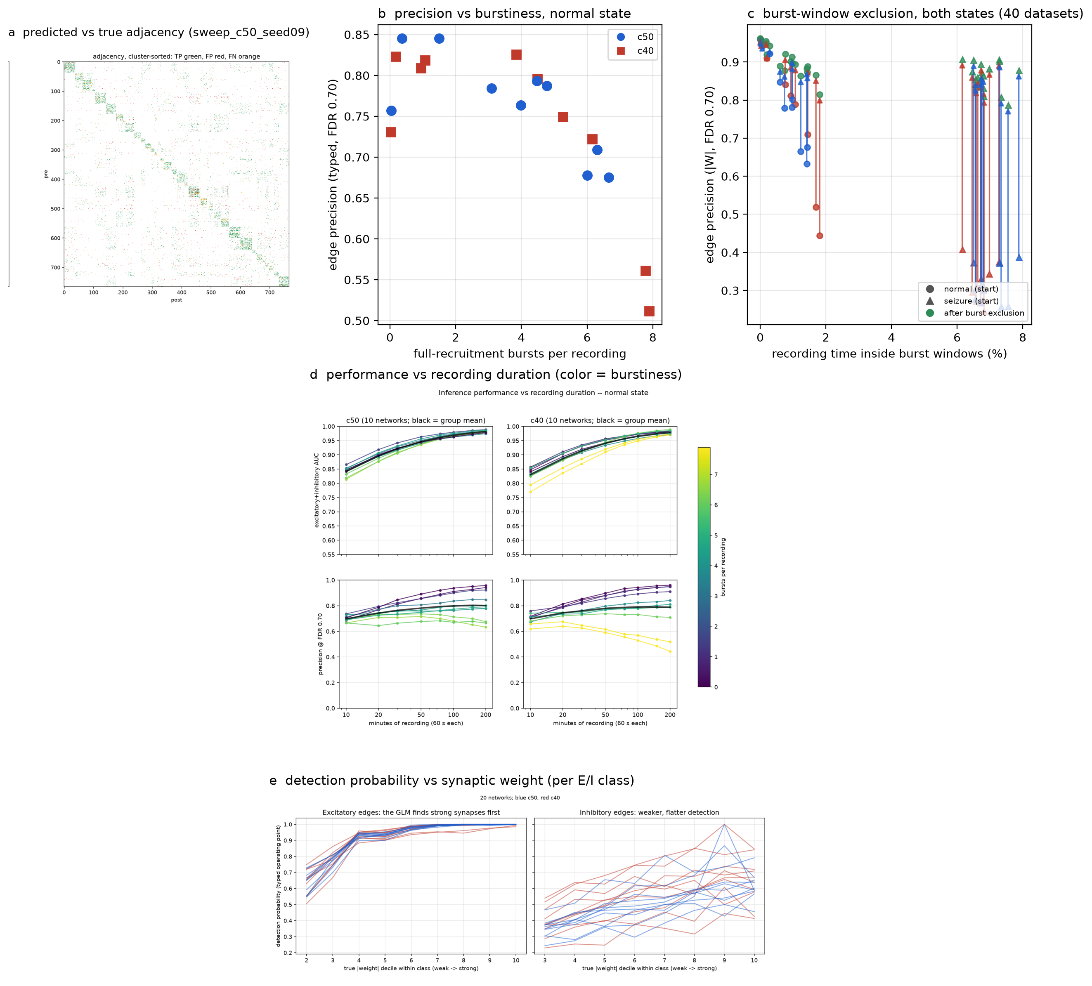
Figure 3. Connectivity inference. (a) Predicted versus true wiring for one network, edges colored by outcome over the spatial layout. (b) Inference performance against recording duration, 10-200 minutes: excitatory AUC (top) and operating-point precision (bottom), one curve per network, 50-cluster and 40-cluster groups in separate columns, group means in bold, curve color encodes burstiness. (c) Precision against full-recruitment burst rate, all 20 networks. (d) Effect of burst-window exclusion: arrows run from full-recording to burst-excluded precision for every dataset in both states, plotted against the fraction of recording time inside burst windows. (e) Detection probability against true synaptic weight decile, excitatory and inhibitory edges separately.

3. Summary
A single mechanism, reduced and accelerated slow afterhyperpolarization, converts a family of structurally diverse clustered networks into a homogeneous, strongly synchronized epileptiform regime. The same manipulation degrades correlation-based connectivity inference from usable (precision 0.85, AUC 0.97) to unusable (precision 0.32), and the degradation is attributable to synchronous common input rather than to firing-rate changes as such: excluding under 7% of the recording recovers most of the lost precision. Burstiness, not network size or density, predicts inference quality across all conditions tested.

